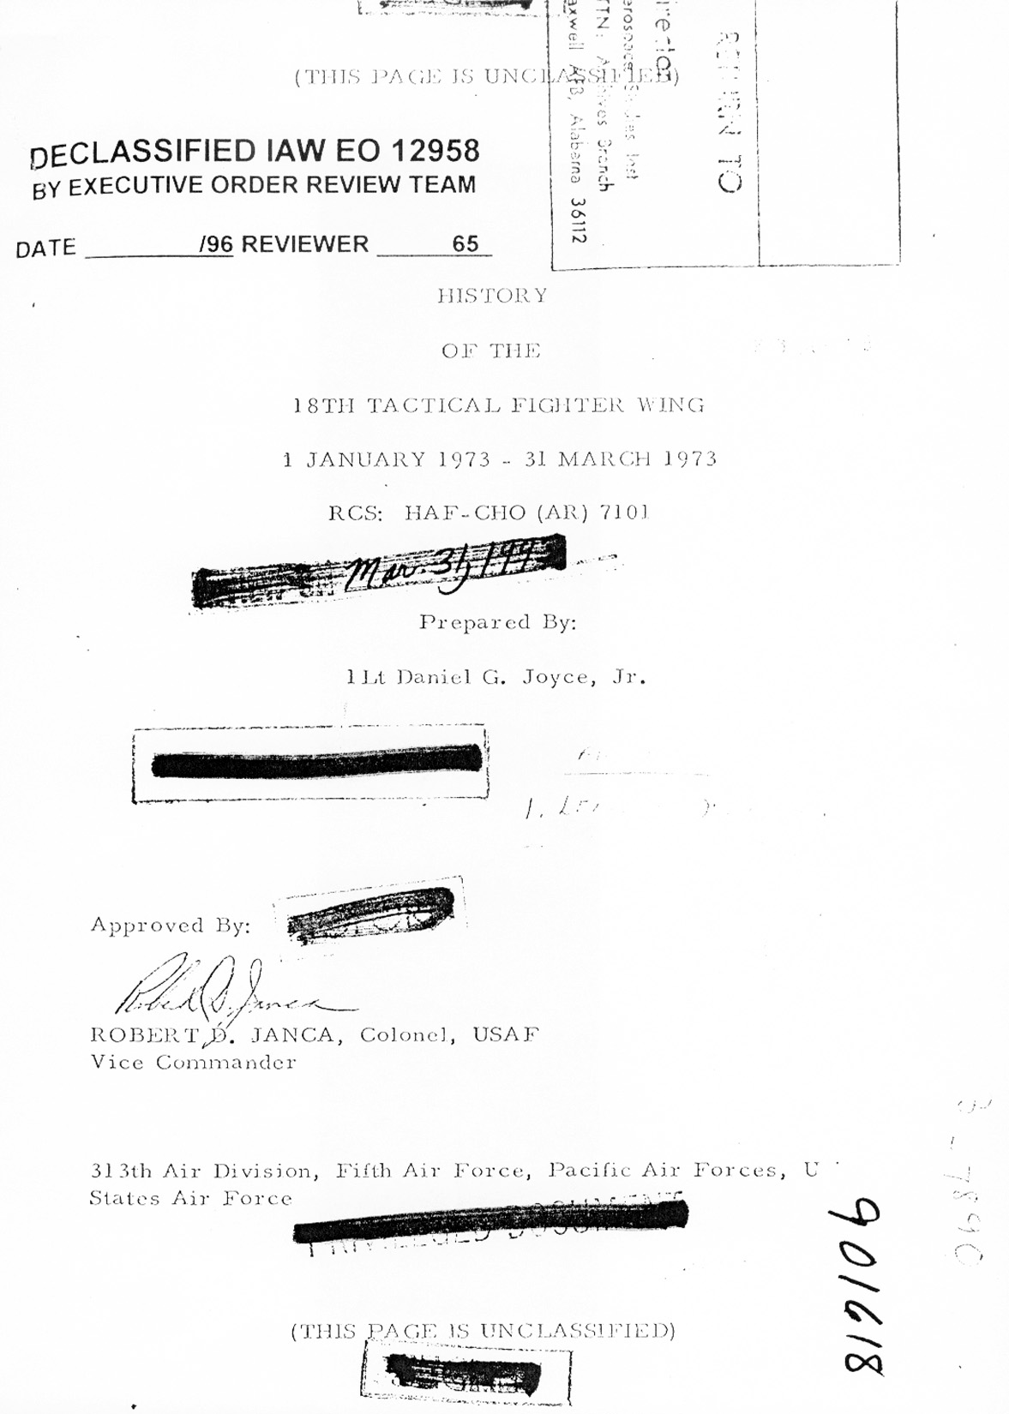
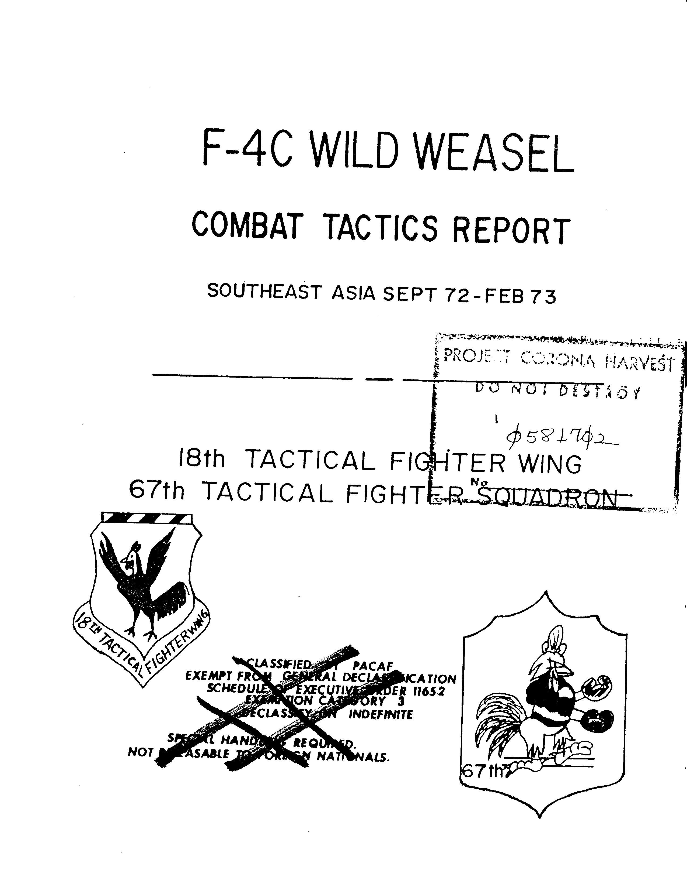
INDEX

PAGE

SUMMARY 1

SECTION I PREFACE 2

SECTION II DEPLOYMENT 3

SECTION III THE MISSION 4

SECTION IV THE THREAT 5

SECTION V TACTICS 8

SECTION VI EQUIPMENT 22

SECTION VII RECOMMENDATIONS 25

SECTION VIII CONCLUSION 28

ATTACHMENT I FLYING TIME SUMMARY 30

ATTACHMENT II APR-25 MJDIFICATION 31

ATTACHMENT III LAU-34 MJDIFICATION 32

DISTRIBUTIQN LIST 33
F-4C WILD WEASEL AIRCRAFT AND TACTICS REPORT

SUMMARY

1. (U) This report is an evaluation of F-4C Wild Weasel aircraft and tactics as employed over North Vietnam during the last quarter of l972 and first quarter of 1973 It also includes a discussion of the mission threat and tactics employed by aircrews of the 67th TFS.

2. (S) The standard detachment mobility manning used for the maintenance package was found to be adequate and provided excellent support, While more aircraft would have been advantageous in a combat zone, the six deployed aircraft proved to be a satisfactory number.

3. (S) The F-4C did an outstanding job in the Wild Weasel role in SEA and was easily adaptable to the development of new tactics because of its excellent maneuverability when compared with other Wild Weasel resources. The RHAW and ECM equipment proved to be very reliable but barely adequate for the current SEA enemy radar environment. The biggest equipment deficiencies were the lack of vector presentation for the SA-2 guidance signals an AGM-45 that can home on the SA-2 guidance signal and dual launchers for the F-4C Wild Weasel.

4. (S) Present training for F-4C Wild Weasel crews was found to be inadequate and it is imperative that Weasels receive realistic training in view of their highly specialized and demanding mission. The training syllabus for the Wild Weasel course at Nellis AFB should be updated with the inclusion of at least one night sortie.

5. (S) Future Wild Weasel aircraft should have RHAW and ECM equipment with built in flexibility in order to counter the enemy’s new tactics and hardware as rapidly as possible. The next generation Wild Weasel should possess an internal cannon and the ability to dispense IR flares and chaff without sacrificing performance or load carrying capability.

6. (U) The F-4C Wild Weasel can do the job for which it was designed. Tactically it provides commanders and tacticians with a versatile and effective Wild Weasel aircraft in threat environments similar to that found in SEA.

SECTION I - PREFACE

1. (U) The first combat deployment of F-4C Wild Weasel aircraft and crews to SEA in September l972 prompted this report. Although the F-4C WW combat experience was limited to escorting highly vulnerable aircraft (specifically B-52 bombers) into areas where radar-directed threats were probable; there are valid initial observations and conclusions ‘to be drawn from these activities The report is not intended to be a complete tactics document, but an evaluation of the capabilities of the F-4C WW and a discussion of the tactics employed by the 67th TFS in SEA.

2. (U) Since this report is a compilation of the thoughts of every pilot and EWO that participated in the mission of the F-4C WW in SEA, different solutions to the same problem are presented in the tactics section because, at one time, they proved to be feasible. Tactics are the primary means of staying ahead of the enemy in the constantly changing electronic battle arena. In addition to tactics, many techniques are mentioned which may be of interest to other Weasel crews and :serve as a foundation for the formation of their own personal techniques

3. (U) Perhaps the most important section of this report is the section devoted to future requirements and recommendations. It is hoped that those responsible for influencing the next generation Wild Weasel aircraft will use what was learned in the design concept of the next Weasel.

SECTION II – DEPLOYMENT
1. (S) Deployment:

- Under OPlan C-106 (Commando Flip), the 67th TFS deployed six (6) F-4C Wild Weasel aircraft and nine (9) aircrews from the 18th TFW, Kadena AB, Japan to the 388th TFW, Korat RTAFB, Thailand on 23 September 1972. The maintenance package consisted of one maintenance officer and approximately 100 airmen from OMS, AMS and FMS. The OMS crew chiefs from Kadena stayed with the F-4C aircraft while specialists were integrated into the 388th TFW maintenance organization. The mobility package deployed with the aircraft was found to be adequate and consisted of the following AFSCs. It must be remembered that the deployment was to an F-4 base.

1 x 271X0 6 x 421X3 3 x 534X0
8 x 322X1P 1 x 422X0 1 x 58lXO
2 x 325X1P 2 x 422X1 2 x 645X0
2 x 328X0 3 x 422X2 1 x 647X0
2 x 328X1 4 x 423X0 1 x 702X0
5 x 328X3 3 x 424X0 1 x 8llXO
2 x 328X4 29 x 431X1C 1 x 922X0
3 x 421X2 8 x 432X0

2 (U) Maintenance Support:

a. Maintaining a high sortie rate with six (6) aircraft was quite an accomplishment. It becomes more significant when it is realized that, due to the long duration of the missions (3-4 hour average), one (1) aircraft was-essentially in phase maintenance at all times, Only a maximum effort by all concerned enabled the 67th TFS to maintain this commendable aircraft in-commission rate. It became commonplace to land and find 18th TFW specialists meeting aircraft in the ‘chocks to debrief problems. This type of support is reminiscent of squadron maintenance and is a strong argument for its return. A flying time summary is presented in Atch 1.

3. (C) Aircrew Experience:

a. The F—4C Wild Weasel aircrews deployed to Korat RTAFB had varied operational backgrounds, All of the aircraft commanders had prior SEA combat tours in F-4 aircraft, while the electronic warfare officer’s background varied from no combat experience to a full SEA tour in the F-lO5F Weasel aircraft. Unit Wild Weasel continuation training prior to the deployment was performed using a single E-Band signal generator located at the Ie Shima bombing range, Okinawa, Japan, All aircrews had attended the Wild Weasel initial or refresher course at Nellis AFB, Nevada within the preceding 18 months.

b. Local orientation at Korat was initially conducted by personnel of the 17th Wild Weasel Squadron and initial flight operations were conducted in conjunction with the F-105G ‘Weasel. aircrews, Theater’ indoctrination consisted- of four combat missions on the wing of an F-105G prior to completing a standardization check, The formed crew concept was adhered to during the entire deployment.

SECTION III - THE MISSION

1 (S) Initial employment of the F-4C WW consisted of escorting .B-52- Strikes into the lower Route Packs of North Vietnam. These missions were flown to familiarize aircrews with the Strategic Air Command operating procedures provide combat exposure in a relatively low threat environment and to make effective use of the increased altitude capability of the F-4C WW. A majority of indoctrination sorties were flown at night with the initial SAM exposure coming in the Vinh, NVN area. Sorties continued to be flown in the Vinh-Than Hoa area in North Vietnam until the resumption of the heavy air strikes in the Hanoi-Haiphong complex on 18 December 1972. By this time all F-4C WW aircrews were proficient in escort procedures and had been exposed to night SAM firings

2 (S) The final phase of combat employment was experienced during the December Bombing Offensive of the Hanoi-Haiphong area.. The 67th TFS aircrews formed part.of the escort forces protecting the B-52’s during the 18-29 December raids

3. (S) Support required for the B-52’s is outlined in 7AF..OP1an 775 (Tiny Tim). While the 7AF OPlan 775 describes in detail the tactics employed by the Weasel force, these tactics are somewhat antiquated for two reasons: First, the tactics are based on the F-105G and as will be explained later, the F-4C WW has more latitude in tactics than the F-105G. Second, the plan was relatively old and the changing electronic order of battle, rules of engagement and enemy tactics dictated modification of the recommended tactics.

4. (5) it was indeed fortunate that the F-4C WW aircrews had the luxury of gaining Weasel combat experience in relatively low threat areas before being directed to work high threat areas. This lack of a realistic training program could have had disastrous results if the F-4C WW’s had been committed to extremely high threat areas at the time of their arrival in the combat theater.
SECTION IV - THE THREAT

1 (S) SAM THREAT: The basic and most important threat with which the Weasel and the supported aircraft were concerned was the SA-2 SAM system. Both the Fansong B and F are deployed throughout North Vietnam. RHAW warnings by various types of aircraft indicated the presence of the Fansong E but this was not confirmed. SAM operator tactics are divided into two sections, one for the lower Route Packs (I-III) and one for Route Packs IV, V and VI.

a, Lower Route Packs: The enemy tacticians are clever, resourceful people who have the ability to adapt quickly to counter USAF tactics. A discussion of current SA-2 tactics is appropriate herein as it is the basis for the development of F-4C Wild Weasel tactics. Generally speaking, the SAM operators were very reluctant to fire during the daylight hours since they would be exposed and subsequently destroyed by the F-4 FAC aircraft that were constantly working the lower Route Pack areas. Therefore, night-time offered the SAM operator the best opportunity to fire and avoid detection. The Fansong TWS radar signal was rarely observed while working in the target area,, It was obvious the enemy: respected the Shrike and did not want to risk being the target for the Shrikes that had been preemptively launched, Even during a SAM launch it was highly unlikely that the Fansong would come on the air and, if it did, was only evident for the last 10-15 seconds of missile flight. The only signals present during the entire launch sequence were the C-Band guidance for the Guideline missile plus several Barlock, Cross Slot, Spoon Rest and Flat Face radars’. Depriving the SA-2 operator of .the use of his TWS radar forced him to use a degraded mode of operation with an associated higher miss distance, Apparently, the enemy used information from the Spoon Rest or Flat Face radars to guide his missiles to the vicinity of the target, and relied on his Fansong for the last 10-15 seconds of missile flight. This type of operation permitted the missiles to come very close to the target and, at the same time, made the Weasel’s task more difficult Another technique employed by the SAM operator was to passively track the B-52 jamming package with his Fansong receiver. Again, this is a degraded mode of operation but one which reduces the possibility of Shrikes homing on the operator’s radar van.. To summarize, the only RHAW indications of a SAM launch were the APR-26 Activity and Missile Launch lights and associated aural tone. By employing the above tactics, the SAM operator deprived the Weasel of a chance to kill the SAM site, but also degraded the effectiveness of the SA-2 system

(1) Note: The above tactics were only used by SAM operators when Wild Weasel aircraft were in the target area. If no Weasels were in the target area, the SAM operators would use their full system to launch.

b. Route Packs IV, V, and VI: The F—4C Wild Weasel experience in RP’s IV, V and VI was limited to night operations in conjunction with the massive B-52 campaign in NVN’s heartland during the last two weeks of December, 1972. On the first night of the raids, the SAM operators used full system, resulting in a Classic launch sequence on the RHAW equipment (ie., APR-25 strobe, rattlesnake audio, TDU E SAM light and APR-26 Launch and Activity lights .with aural tone). With the Fansong on the air for relatively long periods of time, the Weasel had a much improved chance for a kill with the Shrike Probably as a result of several Shrike kills that first night, the SAM operators returned to the tactics they were employing in the lower Route Packs. During many of the SAM firings in Route Packs V and VI the presence of the T-8209 radar was noted. This is a selectable E/I Band radar used in conjunction with the SA-2 SAM system. The T-8209 was developed to counter the extensive use of jamming by the B-52’s and support aircraft and provided the SA-2 site with range information which could be fed into the SA-2 system computer, thereby improving the kill capability of the SA-2 without having to use the Fansong radar in the transmit mode. Azimuth and elevation information for the SA-2 was obtained from the passive tracking of the B-52 jamming package with the Fansong receivers

(1) The addition of the T-8209 to the enemy’s operational inventory made the Weasel’s task more difficult. The narrow beam width of the T-8209 precluded reception on the F-4C RHAW equipment unless the Weasel was positioned in the immediate area of the target.

(2) Wild Weasel support of the B-52 strikes during the last two .weeks of December 1972 was marginal at best. The sheer number of aircraft employed during the raids and the selection of predictable flight profiles for the bomb run were serious limiting factors. The Weasels were effective in denying the SA-2 operator the use of his Fansong radar in the transmit mode. but with the addition of the T-8209, the enemy regained his kill capability against the B-52s. The SA-2/T-8209 combination was not considered a serious threat to fighter aircraft due to the narrow beam width and corresponding difficulty in tracking a maneuvering target.

2. (S) Other Enemy Radars: In addition to the SA-2 SAM system, there were numerous enemy radars in the operating area ranging from the A-Band through the J-Band, These radars consisted of early warning., GCI height-finder, acquisition and AAA fire control systems.. The following is a list of the most prevalent radars encountered in NVN.

a. Early warning - Barlock, Cross Slot, Spoon Rest

b. AAA - Whiff, Firecan, Gundish,

c. Numerous height-finders

d. T-8209

3. (S) AAA: AAA remained, as it had from the start of the SEA conflict, a very real threat and one essential to enemy defenses. It ranged from small arms to radar Controlled 100MM guns. The F-4C WW flew at altitudes that minimized the AAA threat, however the B-52s were vulnerable to the bigger guns if they were radar controlled or elected to barrage fire,

4 (S) Enemy Air Enemy aircraft were not a significant threat to F-4C Weasel operations The MIG 0/B has remained rather stagnant with most aircraft remaining well above the 20th degree of latitude and out of practical intercept range on most of the lower Route Pack m1ssions. MIGs were more numerous in the Route Pack V and VI areas but did not Constitute any significant threat. The occasional foray of a MIG or two at nights into the target area, was little more than a harassment tactic.

5. (S) SA-7: The SA-7 Strella IR-homing SAM missile is portable and can, at any given time, be found anywhere in SEA. In most instances the Weasel and the supported aircraft flew at altitudes and airspeeds that keep them free from this threat.

SECTION V – TACTICS

1. (S) Mission Planning,

a. In order to obtain the best possible results: mission. .planning should be accomplished by the lead crew as a crew effort. Flight size was determined by the threat area into which the B-52s or strike aircraft were flying and Weasel support varied from one Weasel on station around the DMZ to four four-ships with airborne spares for the Route Pack V and VI missions. The airborne spare was used in the target area and effectively made the flight a five-ship At night, with as many as 200 aircraft in the same target area during a 20 minute period, mission planning was even more important if only to prevent mid-air collisions. As a solution to the mid-air problem, when the threat permitted, the rotating beacon was left operating and the white fuselage lights extinguished by pulling circuit breaker A-l5 on panel 3 in the rear cockpit.

b. Pre-mission coordination between the strike-force and the Weasel force was Virtually non-existent but would have been advantageous to all concerned. Future strikes composed of forces from different bases should have the means by which to coordinate their planning and tactics for specific missions

c. Lateral support provided on all missions consisted of KC-135 and EB-66 aircraft. The EB-66 was on station to provide jamming and threat warning to the force. When the strike aircraft ventured into the upper route packs. F-4 MIG CAP and chaff flights were required for their support. The Weasels would also support the chaff flights, as they preceded the strike aircraft into the target area by 10-20 minutes. Because of the number of aircraft in the target area, it was important to plot the position of each of the support flights to reduce the possibility of mid-airs.

d. Target area tactics were determined by relationship of SAM site to B-52 ingress and egress routes. Only after the targets, B-52 routes, and the suspected and confirmed SAM sites were plotted on a map, did mission planning begin in earnest.

e. The support rendered the B-52 or strike aircraft falls into four categories:

(1) First, the Wild Weasel is responsible for threat warning. This was usually a minor role since the B-S2’s RHAW gear is excellent and EB-66 aircraft also issue threat warnings. However, since the SAM operators usually wait until booster separation before coming on the air with the guidance signal, the Weasel may see the launch prior to anyone receiving RHAW indications. To issue effective threat warnings, the Weasel must position himself between the threat and the strike force. It is unlikely that the Weasel would pick up any RHAW indications of a SAM launch (BGO6) unless he is positioned close to a 1ine between the emitter and the target.

(2) Second, the Weasel provides support by offering the SAM operator an alternate target.

(3) Third and most important, the Weasel forces the SAM operator into a degraded mode of operation by denying him the use of the Fansong radar To do this, the Weasel must be so situated that if a SAM were launched at the strike force, a Shrike could be committed on the site and have a time of flight less than that of the SAM missile. When escorting B-52s, this means the Weasel must be within 8-12 NM of the site and have the pointed end of the airplane facing in the general direction from which a SAM launch is expected. Another method of keeping the Fansong off the air is to preemptively fire at known SAM site locations

(4) Fourth, the Weasel can differentiate between everything that is called a SAM at night by inexperienced aircrews (i.e., afterburners, flares, AGM-45/78s) and an actual SAM launch.

f. Night hunter-killer teams composed of F-4C WW and F-4E aircraft loaded with CBUs were used at night in Route Packs V and VI. Once in the target area the teams would split with one F-4C WW and one F-4E strike aircraft being responsible for a given SAM site(s). If the SAM site fired: the Weasel would immediately fire a Shrike at the site and the F-4E would attempt to place CBUs on the site. However, without illumination from the moon and the absence of flares the problems of acquiring a SAM site at night, or in bad weather, are almost insurmountable. The F-4Es were relatively ineffective in attacking SAM sites under these conditions. Perhaps in areas where flares would be practical or when the illumination from the moon is 50% or greater, strike aircraft could effectively bomb SAM sites at night.

g. With the above considerations in mind, the job at hand was to determine the best tactics for a given target. As a matter of professional pride and responsibility, the flight lead assigned himself the hottest and most difficult position. The remaining assignments would take into consideration the abilities of the flight members as well as the operational status of their equipment This often required airborne changes on the way or in the target area. The following diagrams show some typical solutions to problems encountered while operating in NVN.

DIAGRAM NOTES

1. These notes apply to the following diagrams.

2. The predominate theory used in determining all tactics is to stay between the B-52s and the threat whenever possible. The Weasel must be in a position so that when a threat radar is directed. Against a B-52, he is also in the radar beam and pointed towards the threat,

3. Altitude separation was the primary means used to reduce mid-air collision potential when many aircraft were working in close proximity to one another.

4. To avoid the possibility of flying through the B-52 bomb train, Weasels would work no closer than 5NM from the target. This did not necessarily hold for the “Downtown” Hanoi profile.

5. Weasels would try to work no closer than 8 to 10 NM from a known SAM site so as to preserve maneuvering room and visual range.

6. Timing and positioning were critical when the Weasel had to make a specific point and/or cross the B-52 track.

7. It must be emphasized that these diagrams show only examples of tactics that worked at one time and should not be accepted as hard and fast rules, The Weasel game is a volatile and fluid business with no two missions being exactly the same. Therefore, the tactics must be tailored to each individual mission considering B-52 ingress and egress heading, placement of target defenses, etc.

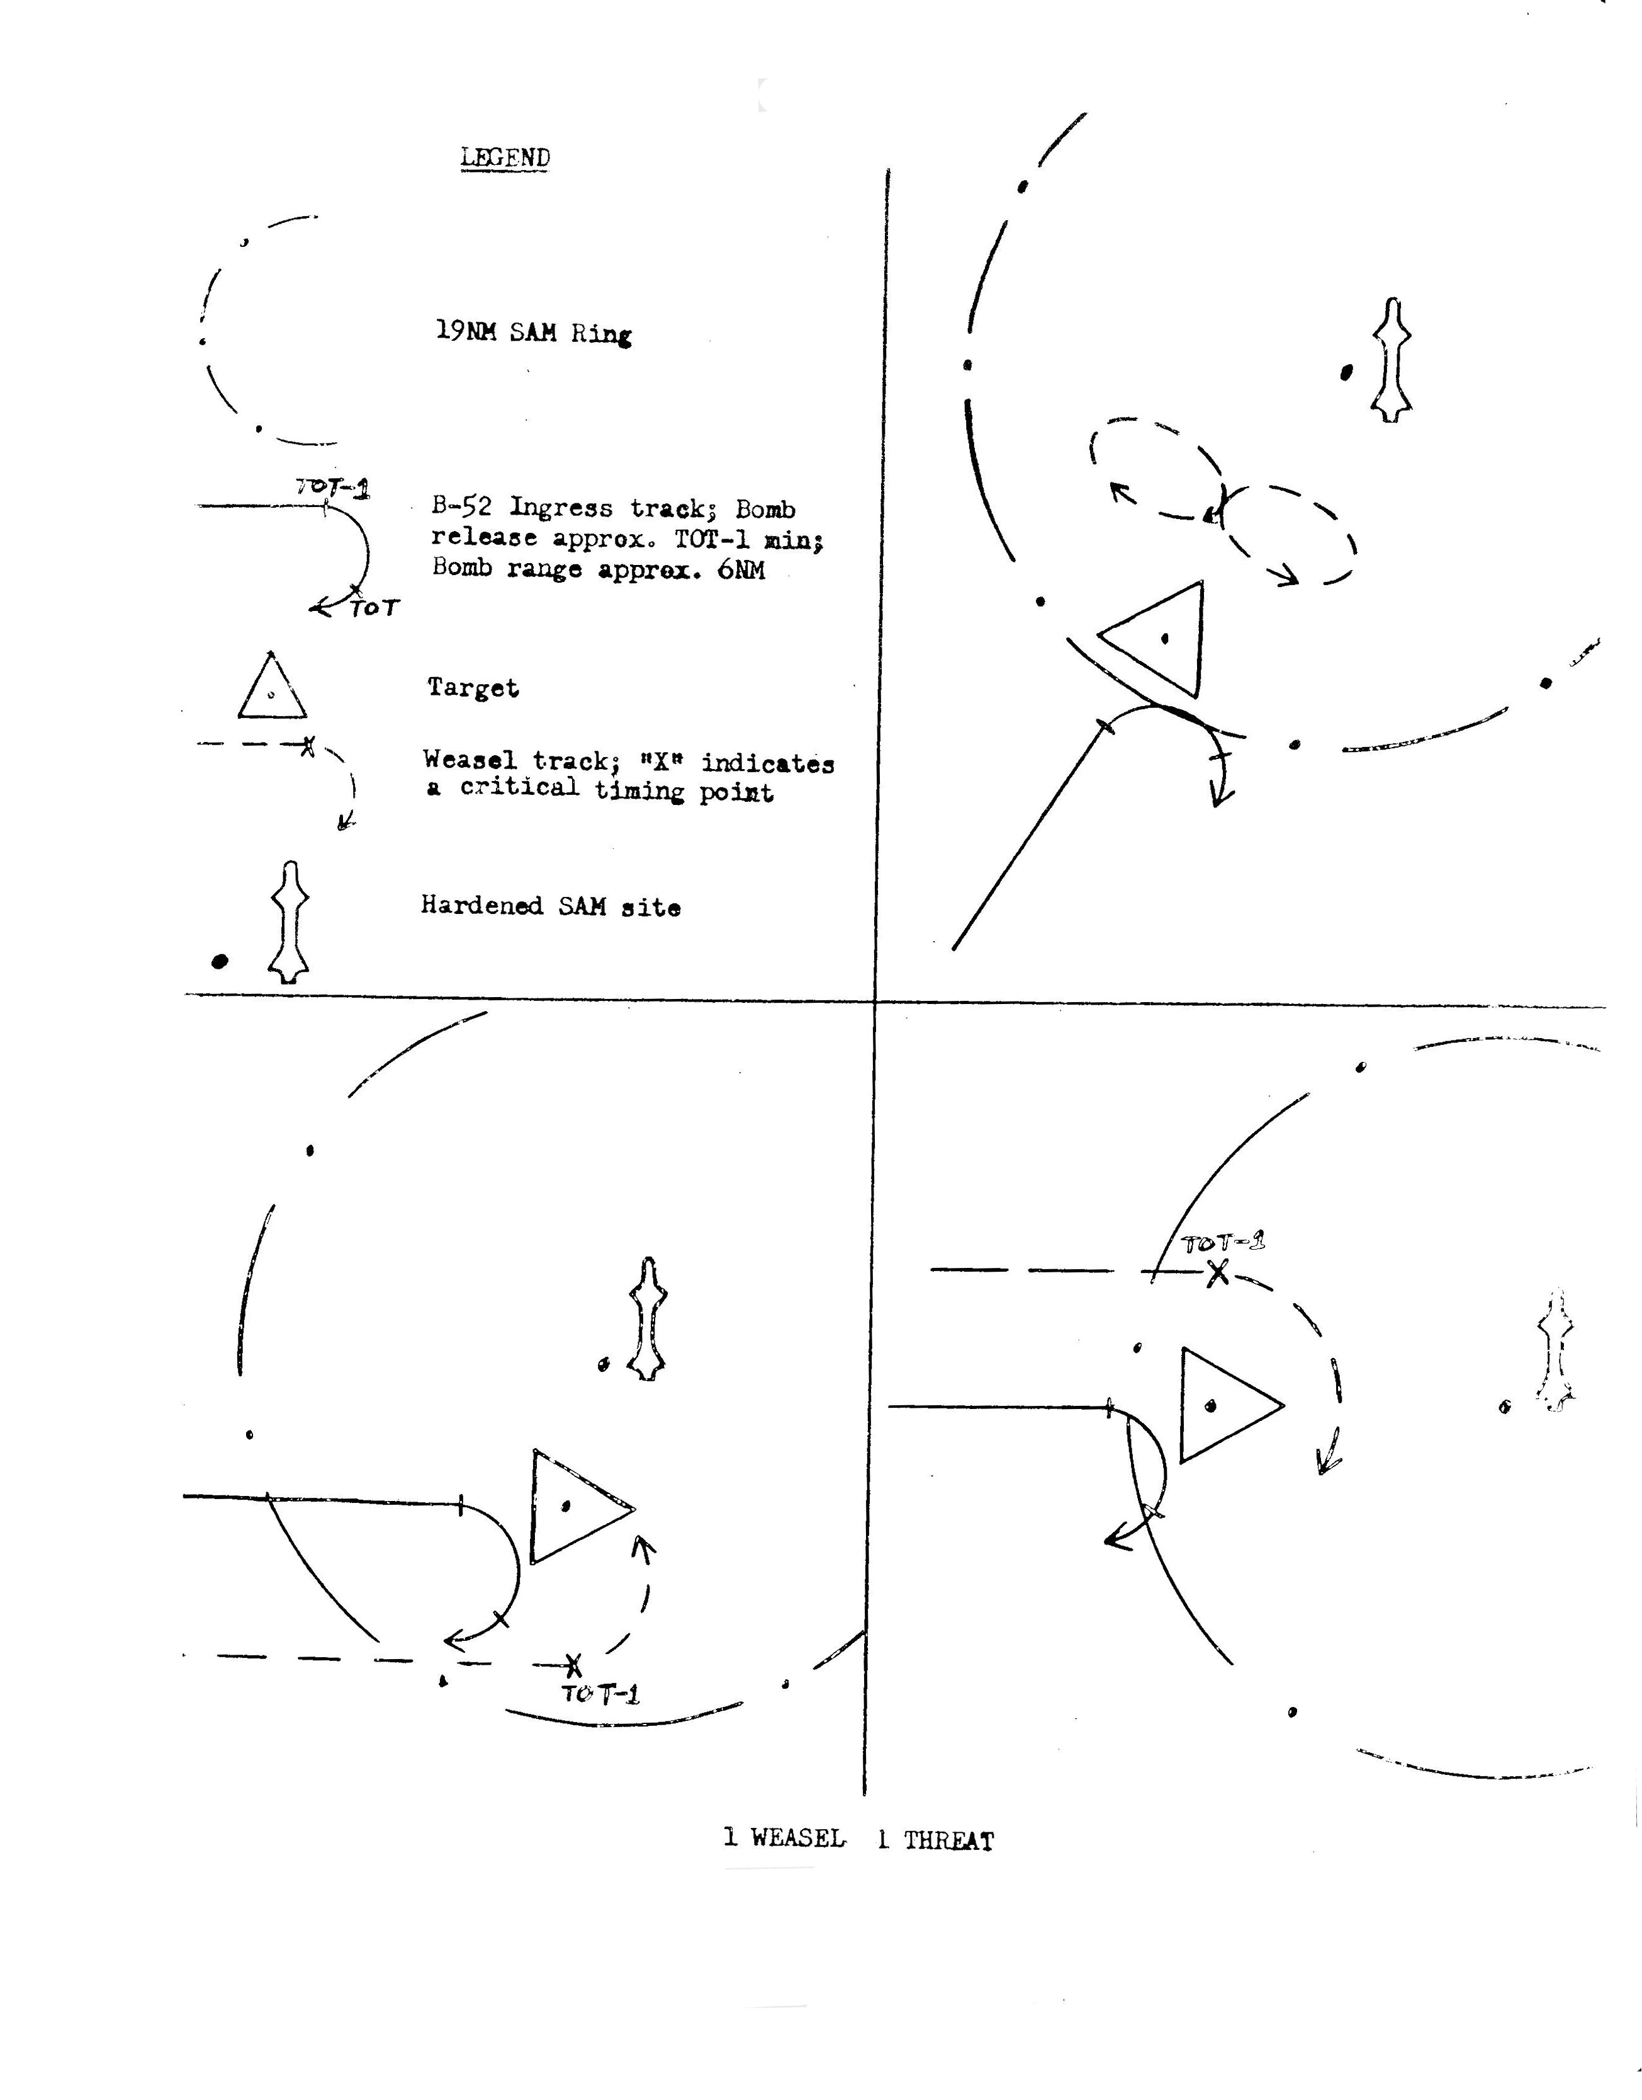
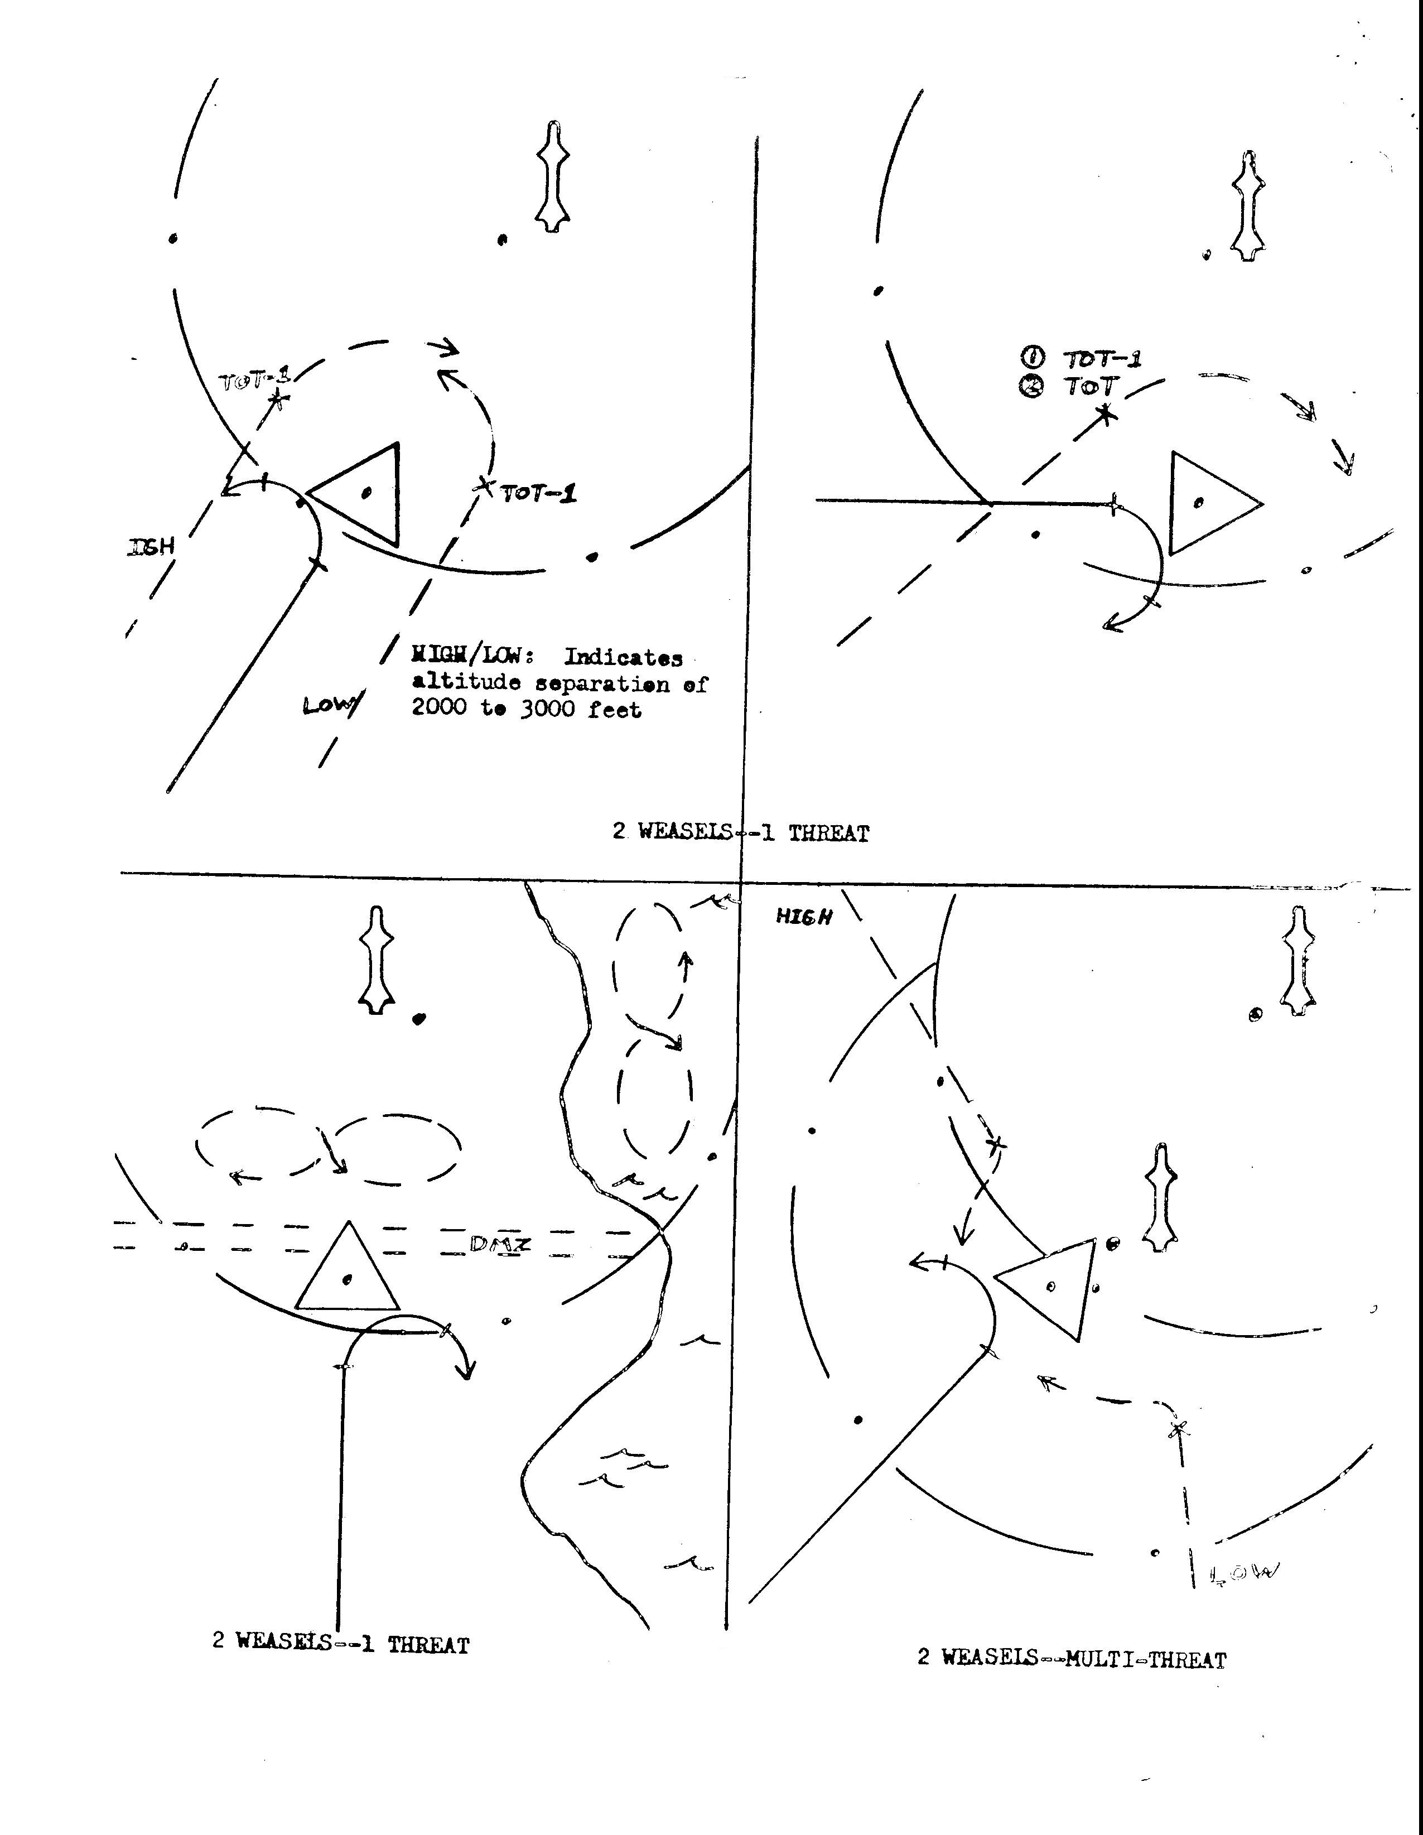
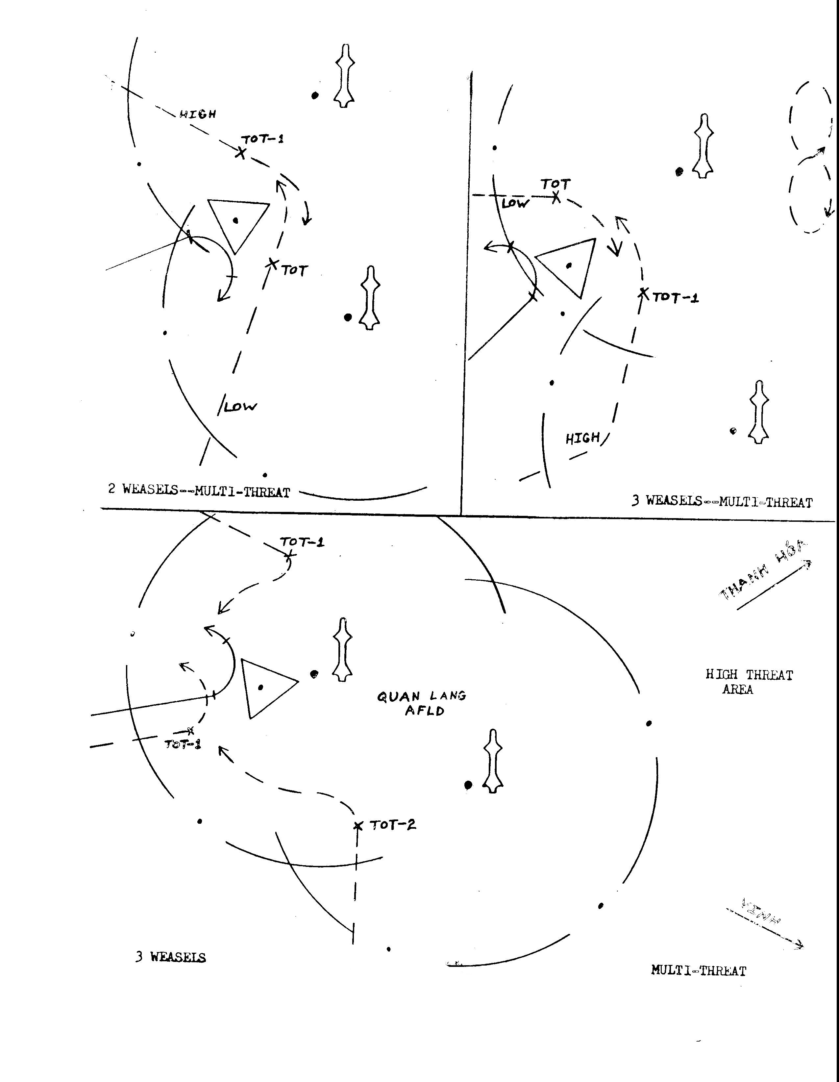

DIAGRAM NOTES

1 The typical scenario for the missions in the Hanoi-Hai Phong area of NVN consisted of 100 plus B-52 Bombers and over 100 support aircraft. There were more than 20 confirmed SA-2 Surface-to-Air Missile sites in the complex along with extensive 37mm, 57mm, 85MM, and 100mm AAA. The weather was generally undercast with a full moon.

2. The Wild Weasel force consisted of F-105G and F-4C Fighters totaling 20 to 25 aircraft, while not true in every case, the F-lO5Gs usually paralleled the B-52’s preplanned track through the target area until reaching a point of relatively low threat for the Bombers. Then they would turn to again intercept a B-52’s track if time and fuel permitted. Due to its greater maneuverability over the F-105G, the F-4Cs were employed more in a Zone type defense₁ setting up orbits close to the target area.

3. For the first three days of .the offensive, both F-lO5s and F-4s flew butterfly orbits about 15 to 20 NM from downtown Hanoi--F-4s high (above 17,000 feet), and F-lO5s 1ow (12,000 to 17,000 feet). Any F-lO5 not assigned an orbit would parallel the B-52’s track, When the orbits were made tighter and moved closer to the target area, the F-105s, not being able to maintain such a tight orbit, went exclusively to escort tactics. On station time often reached 35 to 40 minutes long, making it necessary to stagger flight times on target so that as one flight went bingo fuel, another flight was entering the target area to take its place.

4. At the beginning of the December bombing campaign, the B-52s used parallel or very nearly parallel run-in headings from the west with staggered TOTs. Egress was accomplished by making a hard westward turn back across the mountains into Laos. As the offensive progressed, the attack headings be-came more diverse-even by as much as 180 degrees, and TOTs became more co-incident. Egress became a straight through shot, or as small a turn as possible to exit the quickest way through the least threat,

5. The mission pictured on the following page is typical of those occurring toward the middle of the December bombing campaign. One F-4C was placed over 4 adjacent SA-2 sites on the south edge of Hanoi. The second F-4C was positioned over 3 active sites on the west side of Hanoi. These aircraft were equipped with dive modified AGM 45-3 missiles. Three additional F-4C aircraft were held 15 to 20 NM southwest and north of Hanoi to provide peripheral support. The F-lO5s based their tactics and timing on the ingress/egress headings and TOTs given by SAC. The B-52s flew in cells of three and each F-lO5 would fly approximately the same profile as one of these cells. Once the cell was clear of the high threat area, the F-lO5 would follow another B-52 track through the target area, often flying in the reverse direction of the B-52 cell. The F-lO5 Weasels would continue this criss-crossing of the target area while the F-4 Weasels maintained their zone coverage.

6. It should also be noted that there was lateral support from the U.S. Navy on many of these missions. If the Air Force was concentrating its efforts around Hanoi, Navy Weasel aircraft would patrol the Hai Phong area.

7. At the end of the bombing campaign the Weasel tactics were essentially the same as described above; The F-4C Weasels provided zone or area defense, while the F-1O5G Weasels continuously flew escort through the target area. The B-52 tactics had progressed from single run-ins and targets with staggered TOTs to diverse attack headings on multiple targets with nearly simultaneous TOTs. If the B-52 cell entered the target area from the west, it egressed as nearly straight through as possible to the east, and if it entered from the east, the cell would egress west across the mountains into Laos.

This diagram illustrates the use of multiple Weasels and strikes against multiple targets during the 1972 December bombing campaign. Dashed arrows indicate F-4C Weasel orbits or “areas of responsibility”, dashed and dotted arrows F-105G Weasel tracks, solid arrows B-52 tracks, and dots indicate the approximate position of confirmed SAM sites. For simplicity, not all sites in either the Hanoi or Hai Phong areas are shown. A brief description of tactics used during the offensive can be found on the preceding page
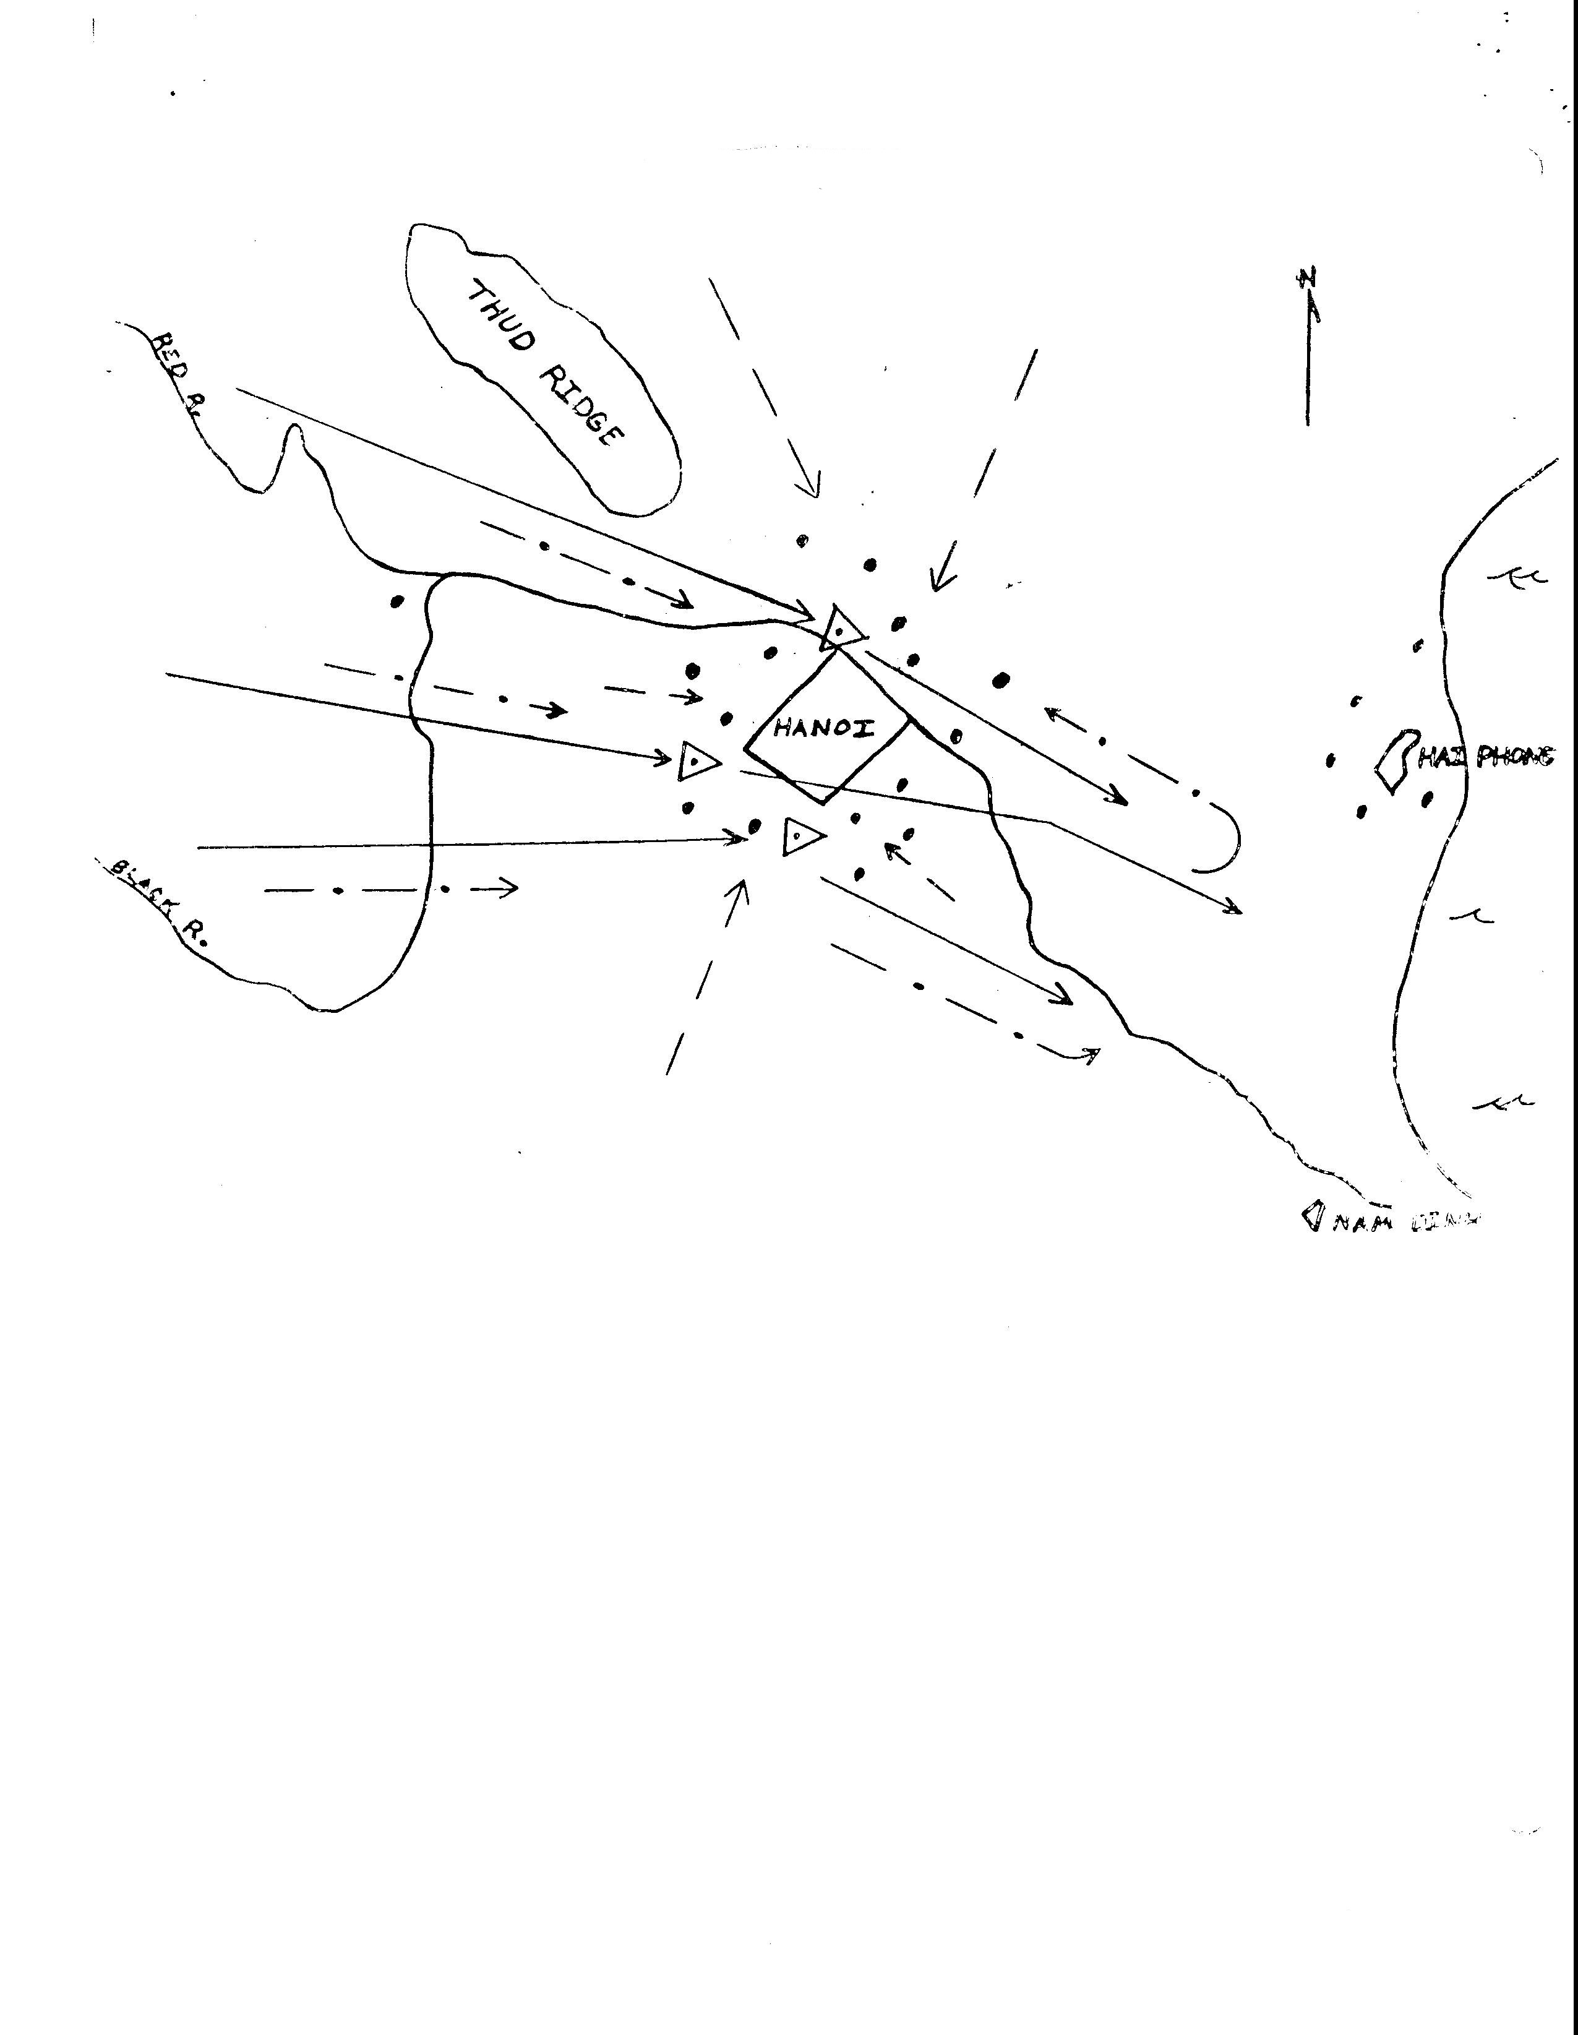

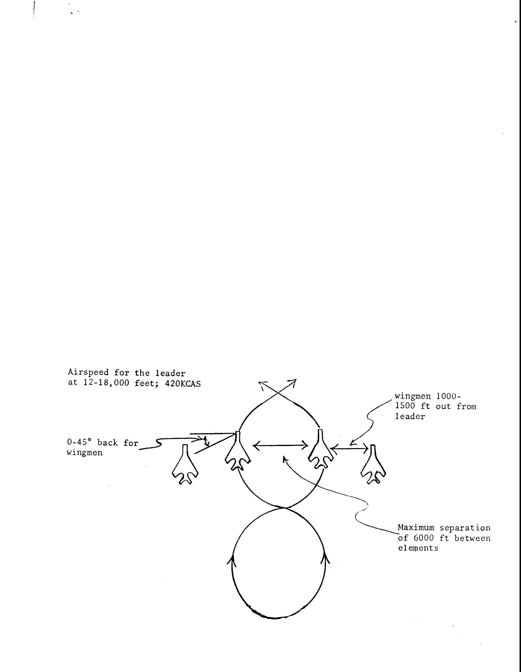
2. (S) Formations

a. When approaching the target area at night, the flight was split and each flight member operated independently as directed by the flight leader. Night Weasel formations are highly impracticable. In the day, if enemy interceptor defenses permit, working single ship allowed for a more efficient coverage of a given target area.

b. In certain target areas, during daylight hours, the target-threat relationship lent itself to working as a flight. The most common two-ship formation was the number two-man flying the number three position of the standard Weasel formation (i.e., 0-60 degrees back and 4000’ to 7000’ out). If additional flight members were added, they would fill in the number two and four positions. This formation was used where enemy interceptors were not a significant threat.

c. In an environment where enemy air constitutes a formidable threat and four aircraft must be employed, the standard Weasel formation is inadequate since the element, in most cases, would lag behind the lead element. In this case a compromise is in order between being effective as a Weasel and preventing enemy aircraft from approaching undetected at six o’clock. The 67th TFS found the best compromise to be a weave formation with number one doing the Weasel work and the remainder of the flight checking six. The following diagram shows the parameters used to fly the weave.

To enter the weave, the leader starts a turn into the element using 45-60 degrees of bank while the element leader turns into the lead element, When the flight paths of the two elements cross, both elements simultaneously reverse the turn. Pulling 1 1/2 to 2 Gs keeps the elements from drifting too far apart. As can be seen, turning continuously provides excellent six o’clock coverage. It’s best to pre-brief the element whether to cross high or low to avoid confusion. This formation gives excellent protection from enemy air but degrades the Weasel’s effectiveness.

(1) This formation was not flown by the 67th TFS in combat, but was developed prior to deployment as a tactic to counter the dense enemy air activity present over Route Packs V and VI.

d. Whether working single ship or in flights, the flight leader must be kept informed of the status of the fire control, ECM RHAW and ordnance of the other flight members, A check was made at the “fence” and updated as necessary. Many types of codes can be developed to transmit equipment status but the simplest one is best. The following codes were used almost exclusively by the 67th TFS.

(1) APQ-100 - Gadget

- APR-25/26 - Primary Gear

- ER-l42 - Secondary Gear

- Shrikes - Right or Left Inboard

- Aim-7 - Right or Left Aft

3. CS) Target Area Considerations,

a. The EB-66 provided the F-4C WW with valuable information that would otherwise be unobtainable with its onboard gear. A four-digit code was used by the EB-66 EWO to provide Wild Weasel crews with the number and type of EW and acquisition radars on the air. This information was passed to the Weasels a few minutes prior to TOT and updated if a change was significant.

(1) Radar environmental codes used by the EB’-66:

1st digit-number of Knife Rests active
2nd digit-number of Moon Faces and Mats active
3rd digit-number of Spoon Rests active
4th digit-number of Flat Faces active

Example: A typical signal environment containing two Knife Rests, no Moon Faces/Mats, two Spoon Rests and one Flat Face would be coded 2-0-2-1 In most cases, SAM firings were correlated with a high level of activity among “non-threat” radars,

b. Once in the target area, the absolute minimum acceptable airspeed is 400KCAS. When working single ship, the Weasel had. the luxury to use all the power desired without having to consider a wingman. Using military power with the standard load of 2x370 gal. wing tanks, 2xAGM-45s, 2XAIM-7s and one ALQ 87 ECM pod in the right forward missile well enabled the F-4C WW to move along at ,9 Mach or 430-450 KCAS at 17 to 20 thousand feet

c. Maximum altitude in the target area is 23,000 feet since higher altitudes degrade the F-4C’s ability to maneuver, either against SAMs or when working signals, and still retain a high energy level without constant use of afterburner,

d. The 67th TFS followed the weather minimums outlined in the USAF FWS Instructional Text, EDPA, F-4 Part Two, Vol, 2. At least 7,000 to 8,000 feet above an undercast is needed to detect and outmaneuver SAMs fired at a Weasel aircraft. This puts an effective limit of 16,000 feet on the cloud tops as weather above this would make the target area unworkable. It must be re-emphasized that the Wild Weasel mission is strictly a VFR operation and should never be employed in unworkable weather. The Weasel has little to absolutely no chance for survival when working below weather minimums.

e. Positioning in the target area can be achieved in many ways, but in any case, the Inertial Navigation System (INS) is the primary aid to navigation, especially at night. Some targets are close enough to TACAN stations that they may also be used for positioning purposes. When in the target area, some crews favored working a series of geographic points, to which they would navigate by using the INS, while others crews simply set in one point and used radials and DME off this point for positioning.

f. When working a target area near a known SAM site, preemptive Shrike launches were a very effective way to keep the Fansong off the air. A preemptive launch must be timed so that the Shrike is in the air during the time that a SAM firing is most probable against the B-52s or other strike aircraft. The most probable firing time can be estimated by analyzing the track of the strike aircraft and its relationship to the SAM site(s). It is also helpful to analyze the recent SAM firings to determine just when the SAM operator prefers to fire, Calling Shrike preemptive launches at night is helpful to the strike flights in order that they do not misidentify the Shrike as a SAM However, if the intent is to really kill a site, then perhaps the preemptive Shrike launch should not be called over the UHF just in case the enemy is listening, Conversely, if the intent is to keep the Fansong off the air, calling preemptive Shrike launches, without actually firing one, could be a useful tactic,

The biggest surprise to most flight crews, with the exception of the EWO, was the extent to which the EWO used the Shrike audio for identification of threat and non-threat radars. The backseater depended almost exclusively on the Shrike audio because of the greater sensitivity of the Shrike as a receiver and the fact that it is a wide open receiver, allowing continuous reception of signals in its frequency spectrum. This, coupled with the fact that the radar environment in the lower Route Packs is relatively sparse, lead to the decision to load two .AGM-45-3s instead of one -3 and one -3A This configuration would still give the EWO a “pair of ears” if one Shrike was fired. In the dense radar environment found in the upper Route Packs, the AGM-45-3A was needed to be effective against the Fansong radar

h. Use of the APQ-100 in the target area was limited by the fact that there was an unacceptable amount of feed-through from the aircraft radar to the Shrike receiver. Normally the aircraft radar was put in standby when selecting the Shrike, A two and one half inch piece of plastic tubing was slipped over the ER-142/APQ-loo switch and the Radar/Heat/Heat Reject switch used to facilitate finding and actuating these switches,

i. Use of the KB-l8 camera system and tape recorder was left to the imagination of the aircrews. The recorder was turned on when entering the target area and the camera used when the chance of obtaining photographic intelligence was indicated. The tape recorder is discussed in more detail in the equipment section of this report.

j. The right inboard Shrike was selected going into the target area so as to preclude the possibility of ripple firing both Shrikes which occurs when the left inboard is selected first. The missile jettison switch was set on the same station as the Shrike selected to facilitate jettisoning the Shrike in case of a hung missile. This is particularly important when operating in close proximity to the U.S. Navy. If a hung Shrike were to launch while the aircraft was pointed toward the Navy, the results could be catastrophic

k. The AIM-7s can be set up to fire with the exception of the Radar/Heat switch and the missile arm switch on the missile status panel. The position of these two switches depends on whether the Weasel wants to listen to the Shrike audio or fire the AIM-7s.

- Safety wire on the missile arm switch and the tank jettison covers was useless and normally broken prior to takeoff to facilitate the operation of these switches.

- Night SAM firings are very easy to see, In fact, everyone within 50 NM can see the SAM(s) and thinks it is coming towards them, Since there is little depth perception at night, it is difficult to tell for whom the SAM(s) are intended until after about 10-20 seconds of missile flight In many cases the crews over-reacted and started their SAM break too early. The important thing to do when first seeing a night SAM launch is to insure the aircraft has the proper energy level. After that, analyze the flight path of the SAM and determine its direction. A SAM that remains in a stationary position on the canopy could mean trouble, If it is determined that a SAM break would be appropriate, remember that night operations increase the chance of vertigo or running into the ground. Crew coordination is very important during night maneuverability and safety of flight dictates that the aircraft commander maintain visual contact with a launched SAM, while the electronic warfare officer concentrates on the aircraft instruments and advises the pilot of any unusual attitudes or conditions leading to out of control flight.

4 (S) Ordnance

a. The F-4C WW generally flew missions with a clean centerline station. Loading four CBUs on a centerline was considered when the centerline fuel tank was not required, as this would have given the Weasel a real capability to kill the SAM site. With just the AGM-45s, kill ability was minimal because of the SAM operator’s tactics discussed earlier.. Loading CBUs on the centerline would not .always provide the solution as the SAM sites generally fire only at night and the weather during the Northeast Monsoon season precluded visual deliveries. Weather permitting, one way to kill a SAM site at night, after it has fired, would be to have an aircraft with an IR source detector onboard look for and mark the hot SAM launcher for a flight of strike aircraft to bomb.

b. When carrying a mixed load of AGM-45-3 and -3As the -3 was carried on the right inboard so that a non-threat radar could be fired upon while the
-3A was retained for the threat radar. The AGM-45-3A was only selected for firing if a Fansong came up and, in this case, ripple fired AGM-45s enhanced the chance of a kill.

c. Dive modified Shrikes were carried occasionally to reduce the Shrike’s time of flight so that it would arrive at the Fansong radar before the SAM arrived at its target, providing the target aircraft was not the one launching the Shrike. Staying on top of a SAM site at night, in a position to fire, is a feat that requires utmost skill and diligence.

SECTION VI - EQUIPMENT

1. (S) RHAW and ECM: The F-4C WW contains RHAW and ECU equipment that is very reliable but old and presently barely adequate for the SEA electronic order of battle. The deficiencies in the electronic equipment, and the proposals or actions taken to correct them, are presented as follows:

a. As presently configured, the APR-25 possesses no capability to display signals outside its logic parameters It was found that an APR-25 logic bypass switch, which would allow the EWO to bypass the present APR-25 E, I and G-Band logic, would be extremely useful in the current SEA environment E and I-Band signals currently outside the logic of the APR-25, such as the Barlock and Cross Slot radars, were becoming threat signals since they were associated with SAM activity. With the logic bypass modification, signals outside APR-25 logic would be displayed on the vector scope and their audio heard over the headsets, Local modification using existing aircraft wiring proved to be the solution and this modification should be performed on all F-4C WW aircraft, The operator controls were located in the rear cockpit just forward of the radar control handle A technical, description of this modification is included in Attachment II to this report

b When the F-4C WW first arrived in the theater, higher headquarters required fighter aircraft going into Route Packs V and VI to carry two ECM pods. (This was later waived for the F-4C WW during the night mission over Route Packs V and VI in the last two weeks of December 1972) Since the left forward sparrow well in F-4C WW aircraft is filled with the KB-l8 camera tape recorder, and ER-142 black boxes, two ECM pods could not be carried without sacrificing one Shrike A proposal was made to certify the left aft Aim-7 well for ECM pod carriage Although the testing involved would he quite extensive, it is still considered absolutely essential

c. Recorder:

(1) The dynamic environment in which the, Wild Weasel works demands a good tape recorder as an intelligence collection and storage device as well as a convenient means to recap the mission chain of events that are easily clouded by the heat of battle The F-4C WW tape recorder provided only marginal performance in these areas.

(2) Mechanical1y, the greatest problem with the recorder was not electronic component failure, but tape drive Jamming and fouling It was most frustrating to both aircrews and maintenance teams to find half the reel of tape wound in a large “rat’s nest” about the drive capstan; especially since the problem has yet to be duplicated on the ground.

(3) Electronically, the recorder offered very poor frequency response and fidelity, making the intelligence gaine4 from intercepted signals quite difficult to obtain and highly inaccurate, Compounding the poor reproduction problem was the lack of a reference tone against which intercepted .signals can be compared (while the original recorder had a tone generator installed, it was removed since its ‘lowest amplitude completely covered everything else on the tape. The recorder’s poor fidelity can also be attributed to the slow drive speed of the 1/4 inch tape and the machine’s susceptibility to “G” load distortion and to its inadequate design.

(4) Systematically, another serious deficiency was that the recorder did not record audio from the AGM-45 Many signals that the Weasels desired to analyze after a mission were lost since the signals did not pass the APR-25 logic or they occurred too rapidly to be located manually on the ER-142, The EWO cannot spend all his time watching the ER-142 for interesting signals to isolate but must allot considerable tune to watching elsewhere for immediate threats to the aircraft, The ability to record from a wide open receiver such as the Shrike would salvage ELINT that is otherwise lost.

(5) An interesting note to the recorder problem was that the small portable cassette recorders, plugged directly into the communications cord, produced a better product than the onboard recorder, both in fidelity and in the number of inputs. Its biggest inconvenience was finding a suitable stowage place.

d. The ER-l42 was found to have a frequency spectrum much too narrow for the SEA electronic threat environment. A receiver with a frequency coverage from the A through J-Band is needed since enemy radars occur in a wide range of frequencies, In addition, frequency and PRF estimation of signals on the ER-142, in combat, is approximate at best. The ALR-.53 will go a long way towards updating the F-4C Wild Weasel so that it can “see’ and analyze enemy radar in a wide frequency spectrum. However, coverage is still needed in the frequency bands below 2,000MHZ and from 11,000 to 16,000MHZ.

2 (5) Aircraft Suspension and Release Equipment:

a Dual AGM-45 launchers for the F-4C Wild Weasel are a definite necessity and long overdue, The advantage to carrying twice the number of Shrikes with little or no degradation in performance should be obvious The 67th TFS is currently following up with several messages on this subject, but nothing substantial has been accomplished to date.

- The F-4C WW aircraft has an automatic stepping relay which steps the firing pulse from the left inboard station to the right inboard station after the left inboard station has fired. This is accomplished providing the bomb button is held depressed. There is no tactical advantage to this system and many disadvantages when carrying a mixed load of A-45s. Again, a local modification to the LAU-34 proved to be the solution to the problem and all LAU-34s used by F-4C WW units should be modified to permit single fire capability. Basically, the modification convinces the aircraft that the left missile is still onboard even though it has been fired, A technical description of this modification is contained in Attachment III to this report.

3 .(U) Miscellaneous Aircraft Systems:

a. It would be very convenient if each cockpit had separate Shrike audio controls. The EWO used the Shrike audio more than the AC -and there is no reason for the AC’s headset to be cluttered with Shrike audio when he should be listening to the WF or interphone.

b. A center mounted third mirror on the canopy bow was installed in the rear cockpit canopy to improve rearward coverage.

c. Cockpit lighting for night combat is totally unacceptable. Individually adjustable lights for the primary instruments would improve a problem area defined many years ago,

4. (S) F-4C WW vs F -1 O5G WW:

a. The F-4 is more maneuverable than the F-l.O5G and can operate at higher altitudes The ability of the F-4 to operate at higher altitudes and still retain the energy and maneuverability needed to evade SAMs enables it to support strikes that otherwise would be diverted due to weather,

b. The increased maneuverability of the F.-4 over the F-lO5G lends itself to the development of new tactics, and tactics, after all, is what keeps the Weasel one step ahead of the enemy. If a threat signal comes up, the F-4 can turn into it more quickly, while retaining a high energy level, and either fire a Shrike or bluff the signal into going down.

c. The F-4 can carry more ordnance than the F-lO5G, The F-4 with dual launchers for the Shrike could easily carry four Shrikes whereas the F-105G has a high drag index with its dual launchers. In addition, a mixed load of Shrikes and CBIJ’s can be carried by the F-4.

d. Considering the hunter-killer role, the F-4C WW would be a more logical choice for the task because of its greater maneuverability and compatibility with other F-4s that comprise half of the team.

e. The above comments are not meant to belittle the F-lO5 Weasel capability, but only to point out some of the differences between the two weapon systems, This commentary provides a yardstick with which to measure the relatively new F-4C Wild Weasel aircraft.

SECTION VII – RECOMMENDATIONS

1. (S.) Future Wild Weasel Aircraft and Equipment:

a. Any future Weasel aircraft must be very maneuverable and capable of high speeds. Currently, the F-4 most nearly fits these requirements. The Weasel aircraft must also possess the ability to carry conventional ordnance as well as Anti-Radiation Missiles (ARMs) to give the Weasel a balanced attack capability, Tandem seating arrangement is imperative due to the need for the pilot to have unrestricted visibility in order to counter SAMs.

b. Flexibility is the key to designing any weapons systems but especially important in the Weasel because of constant ECM/ECCM maneuvering between the Weasel and his adversary. Once the enemy thinks his current equipment and tactics are analyzed correctly, he will surely change them rapidly. The Weasel, to remain effective, must change his equipment and tactics just as quickly. Flexible ECM and RHAW equipment design is essential. For instance, the NVA modification of the SA-2 with the introduction of the Fansong F model rendered the Weasel virtually helpless in supporting strike aircraft with ARM missiles. Flexibility in this case would have been the development and deployment of an ARM that could home on the BGO6 signal and the development of a vector system using the BGO6 signal that would point to the SAM site, This vector presentation would permit the Weasel to look in the direction of the threat, evade the SAMs and locate the site in order to destroy it. This specific instance describes the type of flexibility that must be present in the next generation Weasel aircraft. Without it, the Weasel remains relatively ineffective for periods of time that are unacceptably long when engaged in combat.

c. The following recommendations concerning the F-4D Wild Weasel program are made without complete knowledge of what is planned for the F-4D WW system:

(1) An internal cannon would be of great benefit to the Weasel for several reasons. First, when working the target area, especially in the hunter-killer role, the Weasel presents himself as a vulnerable and desirable target to enemy aircraft, The internal gun would provide the Weasel the ability to defend himself and consequently be less vulnerable, Second, since the Weasel is usually last out of the target area and possesses an excellent knowledge of the working area, he is the most likely candidate for immediate SAR commander if an aircraft is downed,

(2) The new F-4 W should contain an improved tape recorder such as the one currently found on the F-lO5G. The inadequacies of the F-4C WW tape recorder, and the need for a better one, is explained in detail in the equipment section.

(3) Future enemy SAM systems are sure to incorporate some type of terminal homing capability such as is the case with the SA-4 system. It is most likely that this terminal homing will take the form of an IR seeker or Home on Jam feature With this in mind, the future F-4 WW aircraft should be provided with the ability to dispense chaff or IR flares to negate these threats Perhaps a dispenser such as the RF-4 photoflash cartridge system could be installed.

(4) The basic limitations of the AGM-45 Shrike Anti-Radiation Missile (ARM) are that it is too slow and the frequency spectrum too limited. Future ARMs must have the speed to arrive at the SAM site before the SAM missile can arrive at the target aircraft The future ARM must also possess the ability to cover the wide frequency spectrum in which the enemy radars operate.

2. (C) Training:

a. Wild Weasel training is inadequate. Outside the state of Nevada and, until recently NVN, there is no place for the Weasel crews to train with any degree of realism. Realistic training requires a multi-signal environment capable of simulating current threat radars and tactics. Semi-annual unit assignment to Nellis AFB or some other suitable electronic warfare range would help eliminate the current training deficit. Unit training, rather than the present fractionalized aircrew method, is highly recommended.

b. The current Wild Weasel training course at Nellis AFB is an excellent one, however, the many and varied types of missions that the Weasel performs must be included. This must be done with a comprehensive review of what was actually done in the SEA conflict and a clear definition of future Weasel requirements. A night sortie on the Nellis electronic warfare range, during the Wild Weasel course, would be of great benefit in view of the extensive use of Weasels at night in SEA.

c, Due to the extreme difficulty encountered in attempting to establish a realistic SAM-threat-trainjng environment, actual SEA Weasel experience is a unique qualification for assignment to a unit with this specialized mission Those alrcrews that have flown Weasel sorties in SEA should be identified for future ass1gnment to follow-on Weasel units.

3 (C) Force Structure:

a. The Weasel force, as the Weasel aircraft, have maximum flexibility. With the advent of the next generation aircraft in fairly large numbers, the question arises as to how to deploy this formidable force. One answer might be to build a composite wing including F-4 WW, F-4 strike and RF-4 reconnaissance aircraft. The advantages of this arrangement are many. Some of the more obvious ones are discussed below:

(1) The F-4 Weasel operating in the hunter-killer role needs strike aircraft to carry ordnance for the destruction of the SAM site. It would be advantageous for a four ship hunter-killer team to be composed of two WW aircraft and two strike aircraft from the same squadron. The WW and strike crews would work more effectively together as a team if they trained together and arrived at an appreciation for each other’s tactics and techniques.

(2) With the F-4, only the most dense enemy air environment would necessitate additional aircraft for CAP support of the Weasels due to the inherent ability of the F—4 to protect itself.

(3) The reconnaissance contingent of a composite Wild Weasel wing would not have to be as large as current RF-4 squadrons, but perhaps number six to ten aircraft. The addition of the RF-4 would give the Weasels real time intelligence as to the location of SAM sites and other enemy radars. As SAM systems become more mobile, real time intelligence is extremely important if the WW is expected to silence or suppress them. As experienced in SEA, future photo-intelligence will become obsolete in days, perhaps hours, after it is taken. Only with the reconnaissance aircraft and processing equipment co-located with the Weasel force can maximum use of photo-intelligence, be made.

(4) The Weasel force should be a wing of aircraft with F-4 WW, F-4 strike and RF-4’s comprising the various squadrons. This would give the Weasel tactician maximum flexibility and effectiveness for combat.

SECTION VIII CONCLUSION

1. (U) As previously stated, this report is a summary of the tactics and techniques developed and used by the first F-4C Wild Weasel unit to enter combat It also includes an evaluation of the F-4C Wild Weasel weapons System.

2. (S) The two main areas of Concern surrounding the deployment of the F-4C Wild Weasel to Southeast Asia were:

a. Could the older model F-4C structurally withstand the rigors of combat well enough to perform the assigned mission on a sustained basis?

b, If the aircraft could be maintained in the combat environment, would it actually succeed in performing the Wild Weasel mission?

The answer to both questions was a resounding “yes”. Due to the superlative maintenance effort and high interest the air crews displayed, both in the maintenance personnel and in the aircraft status, a very high sortie rate was maintained throughout the combat deployment. Aircraft aborts were rare and not one mission was lost due to the inability of the F-4C Wild Weasel to meet its mission requirements.

3. (S) As to the assigned mission, the F-4.C Wild Weasel proved itself capable of countering the threat environment that exists in Southeast Asia as it was consistently able to execute it’s mission of SAM suppression most effectively. The F-4C Wild Weasel aircraft readily adapted to working with the F-lO5G Wild Weasel in a composite strike force.

4. (S) Not only was the F-4C Wild Weasel able to assume many of the same roles as assigned to the F-lO5G, it also brought some new dimensions to the Weasel force. Compared to the F-1O5G, the F-4C could work at a higher altitude and still maintain its energy. This higher working altitude made the F-4C less vulnerable to AAA, allowed the possibility of devoting more time to visually acquiring and evading a Surface_to_Air Missile, and made possible B-52 strikes that might have otherwise been diverted due to weather. The F-4C also preserved its maneuverability, and was able to out-maneuver the F-105G in almost any situation. For the F-4C, this meant increased survivability from multiple SAM launches whereby the ability to preserve energy under Sustained high “G” loading is highly desirable.

5. (S) The F-4C Wild Weasel aircraft can easily be utilized in a variety of roles, both air-to-air and air-to-ground) while still performing its primary mission. Its air-to-air capability was clearly demonstrated on the night of 20 December 1972 when MIG aircraft attacked the advance Weasel force inbound to the Hanoi target area,. This was the first time the MIG had encountered the F-4C Wild Weasel, and this initial engagement rapidly progressed to a counter-engagement that left the MIG force with a deep respect for the F-4C Weasel in the air-to-air environment. Although no kills were recorded that day, the Weasel formation was successful in routing the MIGs. No centerline ordnance was loaded during the combat deployment; however, it could have been easily accomplished and delivered if directed.

6. (S) The following is a summary of the more important deficiencies identified while operating in the Southeast Asia environment: Higher velocity Shrikes are needed with the capability to guide on signals in all frequency bands, This is necessary in order to gain the capability to isolate and home on the SA-2 guidance signal. Radar Homing and Warning equipment frequency coverage should also be expanded to cover the A through J bands with a more accurate means to determine frequency and PRF (digital readouts would be highly desirable), Also a vector scope for the SA-2 guidance signal is a vital requirement and is urgently needed.

7. (C) Other deficiencies included the need for an improved inflight tape recorder, the inability to defeat the Shrike’s ripple fire mode and to selectively launch AGM-45’s, the lack of a suitable place to hang another jamming pod without sacrificing ordnance, and the vital need for the development of dual Shrike launchers. An F-4C with a mixed load of four Shrikes, two AIM-7s, and six CBUs loaded centerline would be quite a lethal weapon, presenting a versatile and formidable combat capability. Furthermore, the KB-l8 Strike Camera was found to have extremely poor resolution above 8,000 feet and was of little value to the primary F-4C Wild Weasel-mission, In fact, a reconnaissance aircraft or drone can produce intelligence data far superior to that provided by the KB-18 Camera. The strike camera should be removed from the F-4C Wild Weasel aircraft and its space used to carry another jamming pod or components for an improved tape recorder.

8.(U) Most important, the requirement for a more effective continuation aircrew training program is urgently needed. The highly specialized nature of the Wild Weasel mission requires constant updating of training programs and frequent formal review by the combat crew members of new tactics and techniques Essential to the effectiveness of these programs is the necessity for the Weasel crews to work in a training environment that simulates the actual threat,

9. (S) It should be realized that the tactics included in this report may or may not have applicability in other parts of the world. Tactics must be designed around the specific threat to be countered and changed as the enemy changes his tactics and equipment. This report has tried to present the various ways by which the members of the 67th TFS successfully accomplished its specific combat assignment, and it is sincerely hoped that it will lend some meaningful guidance to those aircrews confronted with similar tasks. The F-4C Wild Weasel and the aircrews of the 67th TFS had a combat mission to perform, They performed that mission with a high degree of professional competence and in the finest tradition of the United States Air Force.

10. (U) Any questions concerning the F-4C Wild Weasel role in Southeast Asia can be directed to the 67th TFS, APO San Francisco 96239.

ATTACHMENT I

FLYING TIME SUMMARY (C)

SEP* OCT NOV DEC JAN*** FEB*
Total Sorties 38 150 148 l13** 115 66
Total Hours 84.6 456.6 454.9 348.4** 284.7 130.8
Average Sortie Length 2.2 3.0 3.1 3.1 2.5 2.0
Average Sortie Rate .83 .82 .75** .64
Average Utilization Rate 76.1 75,8 58.1** 47.5
Combat Sorties 20 139 136 104 92 38
Combat Time 54.7 448.4 444.3 340.1** 252.3 76.2
Combat Sortie Length 2.7 3.2 3.3 3.3 2.7 2.0
Combat Sortie Per Day 4.6 4.5 3.7* 3.0
Combat Sortie Rate .78 .75 ,62* .49
Combat Utilization Rate 74.7 74.1 56.7* 42.1

* September and February were partial months.

** Decreased ‘figures reflect higher headquarters directed standdown in preparation for maximum effort 18 through 31 December 1972.

*** January figures reflect reduced number of fragged missions from higher headquarters.

ATTACHMENT II

- APR-25 Logic By-Pass Modification. The steps listed below form the logic by-pass Modification performed on the 67th IFS weasel aircraft.

a Remove ECM pod adapter

b Remove panel 115R.

c. Drop door 22.

d. Remove rear ejection seat

e, Remove right kick panel in rear cockpit..

f. Splice wires into ECM pod adapter cable near top end, Splice wires 9A20, 22A20, 23A20 and 24A20,

g. Run these four wires through the rear panel wire bundle in the area where the ECM pod adapter was removed. These wires enter the area where panel 115R was removed.

h. The wires go through the small hole approximately 8 inches from the front of the 115R area,

i. The Wires are spliced to the following connections: -

(1) 9A20 - J3 Pin 2

(2) 22A20 - J3 Pin 3

(3) 23A20 - J1 Pin 15

(4) 24A20 - J3 Pin 4

j. Cut the following wires on the right ECM pod control: 2TQ1302A20, 2TQI301A20, 2TQ1313A20, and 2TQ1300A20, Then cap the ends coming from the control and splice the wires to the leads coming to the control box.

k. String these wires to the blank panel in the front right console of the rear cockpit. Install three on/off toggle switches, one for each band, and connect wires.

1. Label switches,

m. Check operation,

ATTACHMENT III

LAU-34 MODIFICATION (U)

1. A local modification of the. LAU-34 was developed by SSgt. Louis J Erickson, 388th MMS. Korat RTAFB, Thailand.

2. Reference TO. 1F-4C-2-l8, page 2-8, modification consists of installing a ground wire inside the LAU-34A on pin R. wire number A23420, plug P100 or J7. Leave the existing wire installed.

3 Reference T.O. 1F-4C-2-18, page 2-15, paragraph 2-60, gives a description of AGM-45 release without the modification. When the LAU-34A mounted on either the left inboard or left outboard
stations is modified, the station select relay will not de-energize.

4. Reference T.O 11L1-3-L9-3, page 11, for the internal wiring of the LAU-34.

DISTI BUTION LIST (U)

HQ USAF Commander, PACOM ELINT Center 1
XOO 1
XOOSS 1 Defense Documentation Center 1
XOOTW 1
XOOW 1 WRAMA/MME 1
XOOWC 1
XOOWQC 1 AUL/SE 1
XOOWQ 1
XOOWG 1 USAFTFWC
RDR 1 DR 1
RDRE 1 DV 1
RDQRT 1
IJSAFTAWC
TAC CC 1
DO 1 DO 1
DR 1 DOTE 1
HO 1
AFSC/SDRW 1 OA 1
TEWS 1
AFLC/MMA-1 1 TEWT 1

CINCSAC AFATL
DOPLT 1 DLB 1
DOR 1 DLOSL 1
DOTN 1
DOXTC 1 ADTC
DOXTP 1 TGPE 1
SSLT 1
CINPACAF 1 DLWG 1 1
DOO 1
DOOJ 1 ASD DOOT 1 ENVEA 1
DOQ 1 RWTS 1
OA 1 RWSE 1
PADAF 1 TACSOA 1

CINCUSAFE 1 ESD/ESYD 1
DOA 1
DOQ 1 FTD 1
DOOTE 1 PDJW 1
DOOE 1 PDYF 1

DISTRIBUTION LIST (Continued)

RADC 56SOWg/DO 4
DOTL 1
IRA 1 57FWWg/DO 2
2AF/DO 1 67TRWg/DO 1
3AF/DO 1 3O7STRATWg/DO 4
SAF/DO 3 354TFWg/DO 4
7AF/DO . 2 376SWg/DO 4
7/13AF/DO 3 . 388TFWg/DO 3
7AF/SAC ADVON 1 432TRWg/DO 4
SAF/DO 1 474TFWg/DO 4
12AF/DO 1 544ARTWg I
13AF/DO . 1 3535 Nay Tng Wg/DNTC I
15AF/DO 1 4453CCTWg/DO 1
313AD/D0 1 l7WWSq/CC 1
314AD/VC 1. 42TEWSq/CC 1
3TFWg/DO I 66FWSq/CC 1
8TFWg/DO 4 414FWS/CC 1
18TFWg/DO 2 81TFSq/CC 1
23TRWg/DO - 1 561TFSq/CC 1

Request for copies of this document should be addressed to:
Commander
67th Tactical Fighter Squadron
APO San Francisco 96239

